GMS Requirements Document

Version History

Sl No | Version | Document Section | Change Description | Created  By/On | Approved By/On
1 | 1.0 | First Draft | Sections & Headings | Sreeranjini V  08-Oct-2010
2 | 1.1 | Sequence Diagram  Screen navigation flow | New section  Updated “Project” section | Sreeranjini V  14-Oct-2010

TABLE OF CONTENTS

1 Introduction 3
1.1 System Objective 3
1.2 Purpose & Scope 3
1.3 Scope 3
2 Functional Overview & High Level Workflows 3
3 Use Case Diagram 7
4 System Sequence Diagram 9
5 ER Diagram (Abstract) 10
6 High Level Design 15
6.1 Need of Architecture Design 15
6.2 MVC Architecture (3 tier / n tier architecture) 15
6.3 System Architecture 17
6.4 Architecture of GMS 17
7 Detailed Database Design 19
8 Screen Navigation Flows 20
8.1 Project 22
8.2 institution 22
8.3 HR Management 22
8.4 Masters 23
8.5 Users 23

Introduction

System Objective
Main objective of the system is to make an Online Multi site Grant management System for effective grant maintenance and tracking and the aim of maintaining minimal manual records

Purpose & Scope
Purpose of this document is to describe in brief, the functional aspects, logical flow, architecture and design for developing the Online Multi site Grant management System for MHRD that is expected to provide full featured web based online system.

Scope
This document deals with only high level views. It does not drill down to the screen and field levels of information. Also, it does not list source code or pseudo-code of the system components.

Functional Overview & High Level Workflows

The 2 perspectives to be taken for designing this application are:

The Grantor: the individual/institution/organization assigning the project and allocating the corresponding grant.
The grantee: the individual/institution/organization to which the project has been assigned.

In practice, there will be a scenario of a grantee further allocating sub-projects to a different individual/institution/organization and transferring portions of the grant as funds to them.

For a project, multiple grant allocation is possible .Each grant Allocation is tracked by Sanction Order No.


Since a specific user each, for e.g. corresponding employees, will act as the administrators for the grantor and grantee institution/organizations, he/she will represent the same in all the discussions below.
Project A
Project A1
Project A2
Grantor
Grantee/Grantor
Grantee
Grantee

Projects Creation and Fund Allocation

If the site is act as grantor, then the site user can create new projects. When a new project is created, a grant allocation is also created with amount as zero and grantor as null .Projects will store the PI of the project, start date, end date and type of the project. After creating the projects the user can take the fund allocation screen. In this screen he can see the grant allocation created by default. He can edit the allocation with the allocated amount.

Grant Allocation

If grantor wants to allocate their project to grantee, the grantor should create a sub project of the main projects. Only sub project can be allocated to Grantee. .Also a project can be allocated to one grantee only. If the grantor wants to allocate the projects to multiple grantees, he should divide the projects to sub projects and allocate each sub projects to corresponding grantee. Grantee can map the projects to various departments under their sites. For a project, multiple grant allocation is possible .Each grant Allocation is tracked by Sanction Order No.

Reports

Multiple types of reports are available in the system

- Head Wise Expenditure
- Institution wise Consolidated Expenditure
- Fund Utilization
- Grand Summary Report
- Grant Agency Reports
- Institution Reports
- Project Associate Reports

Now the grantor can view the utilization certificate of grantee directly. The system should provide a provision for submitting the utilization certificate. Granter can view this only after submitting the certificate.

The Grantor workflow is given below
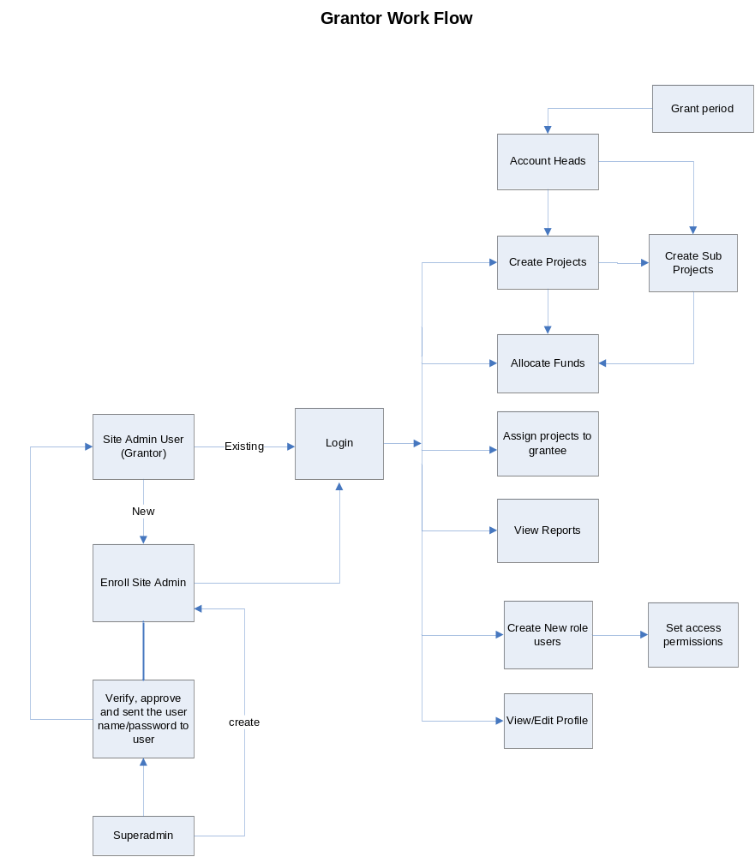

The Grantee workflow is given below:
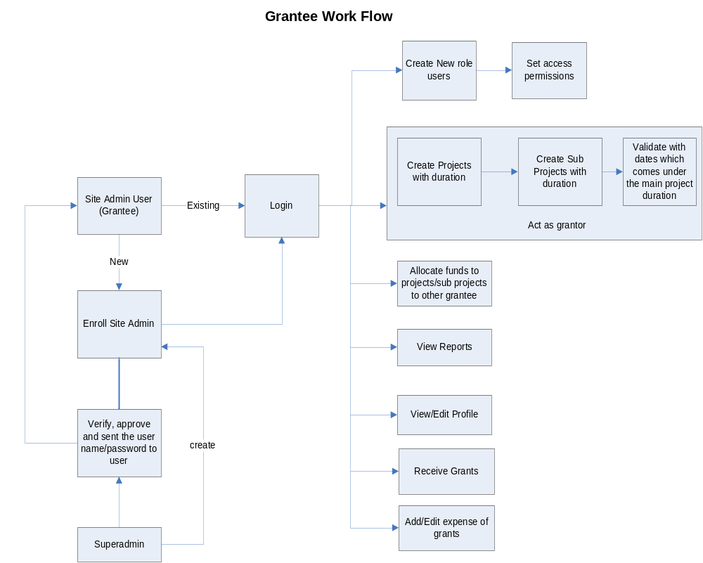

Sub Grant Allocation

Grantee can create sub projects from their allotted projects and can subdivide the projects to other grantee. When grantee sub allocate a sub projects, he became the grantor of that projects.

Allocation of Grants to various heads

Each grant allocation can be divided into various account heads. Head wise allocation is done against a grant period .Account heads and sub account heads can be stored in master table Grant period can also come from master table. Head wise allocation of each grant allocation is shown in a pie chart.

Receive of grants

Grants can be received against grant allocation. Receipt can also be account head wise. Each grant receipt can be tracked by fund received Order no

Expense of Grants

Date wise grants can be entered into System. Daily expenses are entered against head wise allocation. Each expense entry can be tracked against a grant allocation also. Date wise expense can be edited

Pre-grant

After creating the project the institution can publish the notification for the project along with the application form. All institutions in the system will get these notifications and can submit proposals against each notification.

Use Case Diagram

The use cases for this application are as follows:

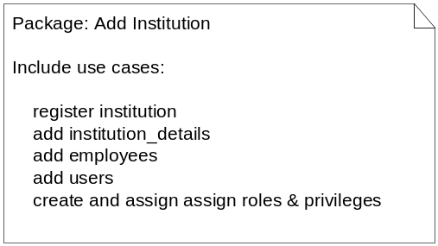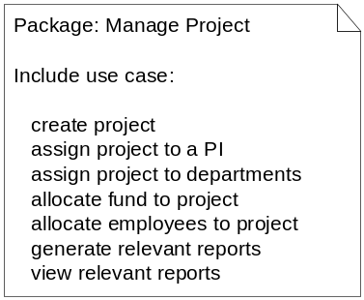

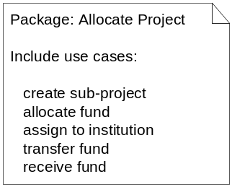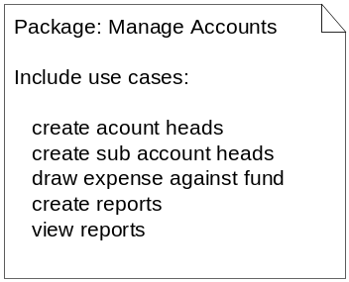

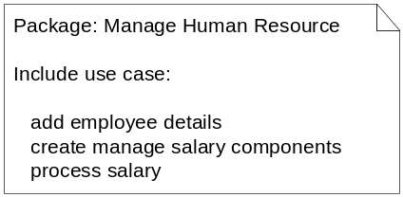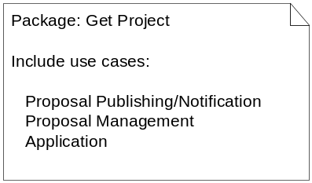

Preconditions & Assumptions

It is assumed that the Grantor has access to the GMS already, has registered its the institution, (any) projects and employees, and is using the modules – accounts, purchase, HR etc. In the diagram below, starting point is the decision on the part of Grantor to allocate the project. Prospective grantees register in the GMS. Notification is sent out along with application form requesting for proposals. Eventually, the Grantee gets assigned to the project. The diagram represents only the activities in this time period – till project closure.

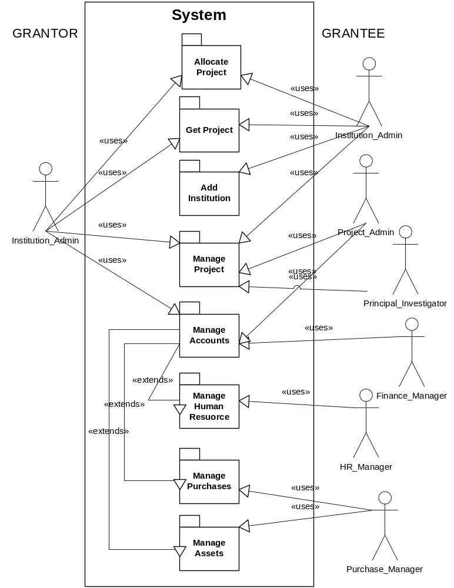

System Sequence Diagram

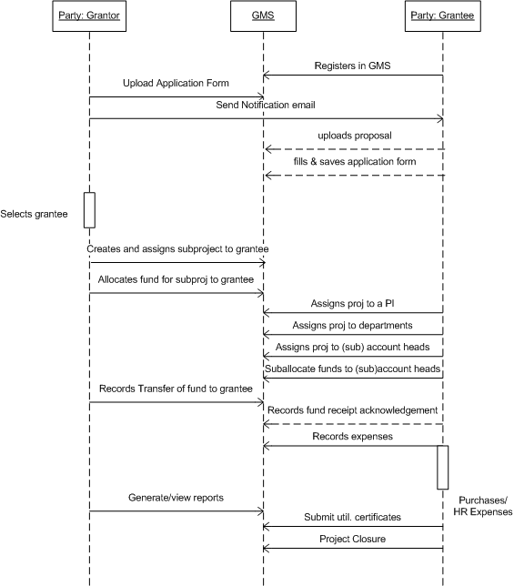

ER Diagram (Abstract)

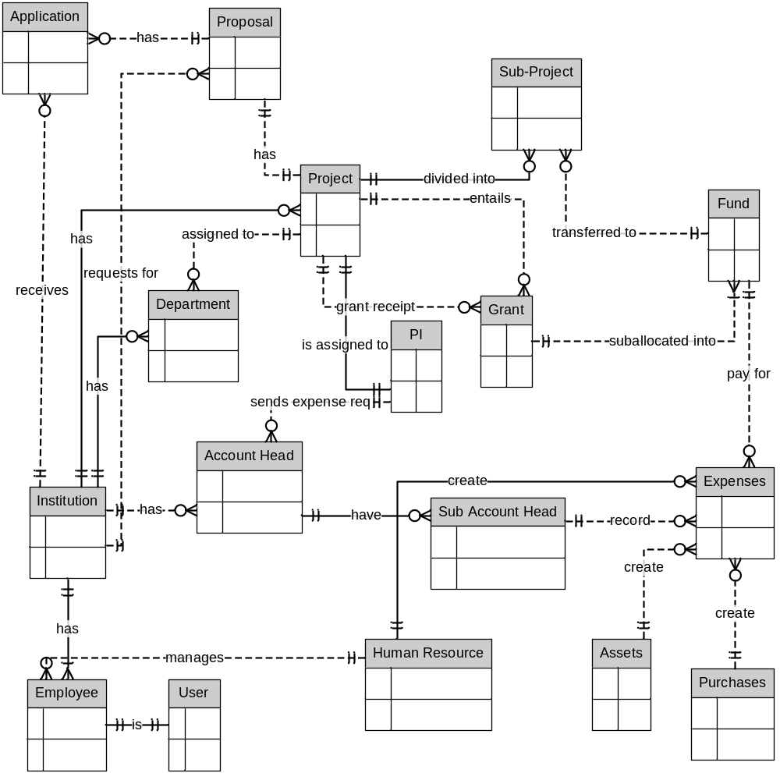

(Detailed database diagram has been inserted in section 6 below)

Entities & Required Information (Abstract

Entity | Associated Data (Attributes)
Attachment | - Attachment path  - Attachment id  - Domain  - Domain id  - Opened y/n
Authority | - Active y/n  - Authority  - Description
Fund | - Amount  - Date of transfer  - Associated grant allocation
Grant | - Grant allocation type  - Amount allocated  - Code  - Date of allocation  - Associated Granter  - Grant period  - Default_y/n  - Start date  - End Date  - Associated Party  - Associated Project  - Allocation remarks  - Sanction order no:  - Grant split amount  - Associated Account head  - Split Description  - Date of tracking  - Grant allocation status  - Tracking remarks
Expenses | - Bank name  - Date of expense  - DD branch  - DD date  - DD No:  - Expense description  - Expense amount  - Mode of payment  - Associated Project
Expense Request | - Associated Account head  - Fund available y/n  - Requested amount  - Requested date
Fund Transfer | - Amount  - Date of transfer  - Associated Grant allocation
Grant Receipt | - Amount  - Bank name  - Date of receipt  - DD Branch  - DD Date  - DD No:  - Description  - Associated Grant allocation  - Associated Grant allocation split  - Mode of payment  - Associated Project  - Reference id  - Associated Fund transfer
Investigator | - Address  - Associated Department  - Designation  - Email  - Name  - Associated Party
Item purchase | - Asset code  - Bill No:  - Cost  - Date received  - Name  - Order no:  - Associated Project  - Remarks  - Status
Notification | - application form  - description  - eligibility document  - notification code  - notification date  - Associated project  - Proposal submission last date
Notification attachment | - attachment path  - attachment type  - Associated notification  - Associated proposal
Notification email | - Associated Notification  - Associated Party
Party | - Address  - Code  - Email  - Name of the institution  - Party type  - Phone
Department | - Department code  - Name  - Associated Party
Person | - Account Expired  - Account locked  - Email  - Password  - Password expired  - User real name  - Username
Employee | - Dob  - Employee name  - Employee no:  - Employee designation  - Associated Project  - Joining date (project)  - Relieving date (project)  - Status  - Designation _last organization  - Last Organization name  - Joining date (last Organization)  - Relieving date (last Organization)  - Status  - Exam Name  - Pass out year  - Percentage of marks  - Status  - University  - End date  - Salary amount  - Salary component  - Status  - With effect from
Project | - Code  - Name  - Project Type  - Project duration  - Start Date  - End Date  - Date of tracking  - Percentage of completion  - Project status  - Remarks  - Associated investigators  - Investigators’ roles
Proposal | - Code  - Description  - Locked y/n  - Associated notification  - Associated Party  - Proposal documentation path  - Proposal submitted date
Proposal Application | - Application submitted date  - Associated id
Proposal application ext | - Field  - Associated proposal
Role Privileges | - Action name  - Controller name  - Description  - Associated party  - Associated role
Utilization | - Associated Grantee  - Associated Project  - Associated Grant Period

High Level Design

Need of Architecture Design
Major design decisions of the system are listed as follows;

- Easiness and reuse.
- Highly reliable and scalable.
- Secure.
- Security.
- Use of standards makes easy to develop and maintain.
- Reduce the maintenance cost.

MVC Architecture (3 tier / n tier architecture)
M – Model
V – View
C – Controller
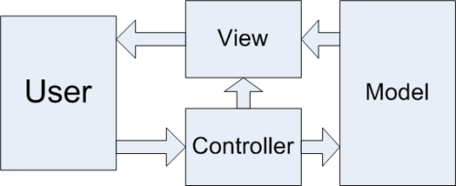
Database
Sends HTTP Request

Model-View-Controller architecture is very useful for interactive web - applications/portals.

MVC design pattern allows to the user to make the application modules to be loosely coupled thus making the code more flexible when the client requires to add few more functionalities to the existing application.

MVC allows introducing the changes to the user interface without affecting data handling mechanism. Even it allows the data to get reorganized without demanding for any change to the user interface.

Architecture reduces the coupling between business logic and data presentation to end user. This model divides into three layers:

1. Model: Contains the business logics and functions that manipulate the business data. It provides updated information to view domain and also gives response to query. And the controller can access the functionality which is encapsulated in the model.

2. View: View is responsible for presentation aspect of application according to the model data and also responsible to forward query response to the controller.

3. Controller: Controller accepts and intercepts user requests and controls the business objects to fulfill these requests. An application has one controller for related functionality.

System Architecture
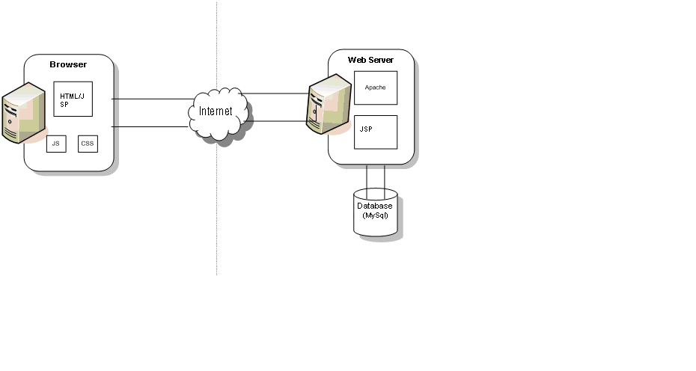

Architecture of GMS
MGMS is built up on Groovy on Grails frame work. MySql data base is used as backend tool.For graphical dispaly Google Chart is also Used

Groovy on Grails
Grails is an advanced and innovative open source web application platform that delivers new levels of developer productivity by applying principles like Convention over Configuration. Grails helps development teams embrace agile methodologies, deliver quality applications in reduced amounts of time, and focus on what really matters: creating high quality, easy to use applications that delight users. Grails naturally complements Java application development since it is built on Spring and based on Groovy, the leading dynamic language for the Java platform.
Groovy is the leading open source dynamic language for the Java Virtual Machine that offers a flexible Java-like syntax that most Java developers can learn in matter of hours. Groovy provides features seen in other dynamic languages like Ruby, Python or Smalltalk. Groovy really shines in its ability to easily define internal Domain Specific Languages (DSLs) that can be used as an abstraction layer that enables non-technical subject matter experts to codify business rules.
The combination of Groovy and Grails offers productivity benefits rivaling Ruby on Rails, but on the proven, scalable, and seamlessly integrated Java platform. SpringSource offers a support subscription for Groovy and Grails that provides the expert developer and production support, and legal indemnification businesses need to confidently deploy Groovy and Grails technologies across the enterprise.
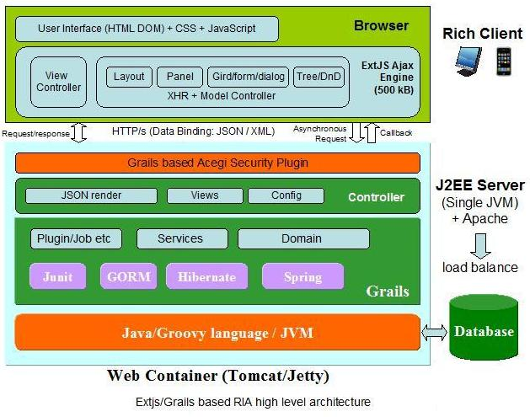

Google Charts
The Google Chart API is an extremely simple tool that lets you easily create a chart from some data and embed it in a webpage. You embed the data and formatting parameters in an HTTP request, and Google returns a PNG image of the chart. Many types of charts are supported, and by making the request into an image tag you can simply include the chart in a webpage.
Currently, line, bar, pie, and radar charts, as well as venn diagrams, scatter plots, sparklines, maps, google-o-meters, and QR codes are supported.

Detailed Database Design

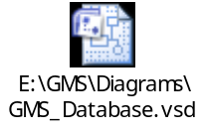

Screen Navigation Flows

Main Menu

Navigation bar displayed on the left on the left throughout the application after logging in.
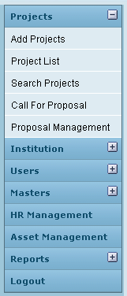
At a time, only one menu can be expanded, rest all remain in collapsed state.
Main Menu | Sub-menus | Remark
Projects | Add Projects
 | Project List
 | Search Projects
 | Call For Proposal
 | Proposal Management
Institution | Add Department
 | Institution List
Users | Add User
 | Users List
 | Project Permission
 | Access Permission
 | Role Privileges
Masters | Grant Agency
 | Account Head
 | Grant Period
 | Project Type
 | Attachment Type
 | PI
 | Add Role
 | Employee Designation
 | Salary Component
HR Management
Asset Management
Reports | Project Status Reports
 | Utilization Certificates
 | Statistical Reports
 | Grant Agency Reports
 | Audit Logging Report
 | More…
Logout

Screen Navigation flow

Each flow has been extended to the last screen possible, without breaking the flow.

“Back” key will always take the user to the previous page. In the following diagrams, this is not considered. Only the flows maintained by clicking links and buttons have been considered.

Once a registered user logs into the application, the default home screen is “Project List” which displays all the projects currently assigned to the particular institution to which the user belongs.

Login
Login Page
Create site admin
Forgot your password?
Edit Project
Projects List
Add PI
Edit
Add Department
Edit
Fund Allocation
Edit
Project Info
Allocation
Project Closure
Expenses
Reports
Sub-allocate project
Head-wise Allocation
Edit
Edit
Allocate
Upload Attachments
Grant Withdrawal/ Closure
Fund Transfer
Edit
Grant Receipt
Record Expenses
View expense for a period
View expenses head-wise
Edit
Utilization Certificates
Submit Utilization Certificate

Project

Project
Add Project
Project List
Search Projects
New Notification
Appl Form View
Call for Proposal
Proposal Management
Add PI
Edit
Add Department
Edit
Fund Allocation
Edit
Notification List
Proposal View
Publish
Edit
Proposal List
Notification View
Upload
Apply
(Given above)

institution
Proposal Management
Call for proposal
Search Projects

Institution
Add Department
Institution List
Edit
Edit

HR Management
HR Management
Current Projects
Edit
Qualification
Experience
Add Employee
Salary

Masters
Masters
Grant Agency
Account Head
Grant Period
Project Type
Attachment Type
PI
Edit
Add Role
Employee Designation
Salary Component
Edit
Edit
Edit
Edit
Edit
Edit
Edit
Edit

Users

Users
Add User
Users List
Project Permission
Access Permission
Role Privileges
Edit

General Requirements

Home Page: The company logo will be located at the top left hand corner of the page
A global navigation bar will be located below the logo
Rollovers will be used for the global links to the other web pages
- Reservations
- Facilities
- Directions
- About Us
- Events
- Contact
- Employment
- Site/Map
- Legal/ Privacy
The bottom of the page will contain links to information regarding copyright and privacy statement.

About us: The logo and home text link will provide a link back to the home page.

